**TABLE OF CONTENT**

*LEARNING UNIT 4: Fostering Cross-Cultural and Cross-Religious Dialogue 2*

*SECTION 1: Theoretical Foundations 2*

SECTION OVERVIEW 2

LEARNING OUTCOMES 3

LESSON 1: Core Concepts and Definitions 4

LESSON 2: Theoretical Models And Frameworks 8

ASSESSMENT 14

REFERENCES AND ADDITIONAL RESOURCES 18

*SECTION 2: Practical Applications of Cross-Cultural and Cross-Religious Dialogue 19*

SECTION OVERVIEW 19

LEARNING OUTCOMES 20

LESSON 1: Case Studies of Dialogue in Practice 20

LESSON 2: Independent Analysis of Success Stories 25

ASSESSMENT 29

REFERENCES AND ADDITIONAL RESOURCES 32

# 

# LEARNING UNIT 4: Fostering Cross-Cultural and Cross-Religious Dialogue





## SECTION OVERVIEW

This section provides a comprehensive theoretical foundation for understanding and engaging in cross-cultural and cross-religious dialogue. It explores core concepts such as cultural competence, intercultural sensitivity, and interfaith principles, equipping learners with the knowledge required to navigate diverse environments effectively.el aynası, metin, iç mekan içeren bir resim

Yapay zeka tarafından oluşturulmuş içerik yanlış olabilir.

Learners will delve into the historical and social contexts that have shaped cultural and religious diversity. These insights provide a crucial backdrop for understanding how societies evolve and interact in an interconnected world. The section also addresses common barriers to dialogue, such as stereotypes and biases, while introducing practical skills like active listening, empathetic communication, and self-awareness.

By integrating theoretical frameworks such as Edward T. Hall’s Cultural Dimensions and Bennett’s Developmental Model of Intercultural Sensitivity (DMIS), the section provides structured approaches to analyzing cultural dynamics. Learners will gain tools to critically examine these frameworks and apply them to real-world challenges, ensuring a solid foundation for building inclusive and constructive dialogue in multicultural and multi-faith contexts.



## LEARNING OUTCOMES

By the end of this section, learners will;gökyüzü, kişi, şahıs, bulut, top içeren bir resim

Yapay zeka tarafından oluşturulmuş içerik yanlış olabilir.

* Understand the role of historical and social contexts, such as migration and globalization, in shaping cultural and religious diversity.
* Define and apply key terms, including cultural competence, intercultural sensitivity, and interfaith dialogue principles.
* Identify and analyze common stereotypes and misconceptions that hinder effective dialogue.
* Demonstrate active listening and empathetic communication in diverse cultural and religious settings.
* Reflect on personal biases and assumptions to build self-awareness in intercultural interactions.
* Develop strategies to facilitate dialogue and foster inclusive environments.
* Use theoretical frameworks, such as Edward T. Hall’s Cultural Dimensions and Bennett’s DMIS, to analyze and resolve conflicts in cross-cultural and interfaith contexts.



## LESSON 1: Core Concepts and Definitions

**1.1 Understanding Key Terms**

Cross-cultural and cross-religious dialogue relies on key concepts that foster understanding and cooperation. Culture encompasses shared values, traditions, and behaviors that influence perspectives. Religion, on the other hand, provides beliefs and practices that shape meaning and identity. Both culture and religion are central to individual and collective identity and frequently intersect in shaping societal dynamics.

Intercultural competence—the ability to interact effectively and respectfully across differences—requires sensitivity, adaptability, and mutual respect. Mastering these concepts equips individuals to engage in inclusive, meaningful dialogue.

**1.2 Historical Contexts of Cultural and Religious Diversity**

The diversity of cultures and religions has been significantly influenced by historical phenomena such as migration, globalization, and colonialism.

Migration has historically been a key driver of cultural exchange. For example, the ancient Silk Road not only facilitated the trade of goods but also enabled the dissemination of religions like Buddhism, Islam, and Christianity across continents. Today, migration continues to enrich societies, introducing varied cultural perspectives and religious practices.

Globalization has further amplified these interactions by breaking geographical barriers. Advances in technology and trade have accelerated the exchange of ideas, fostering awareness of different cultures and religions. However, globalization is not without challenges. While it promotes interconnectedness, it also risks cultural homogenization and the commodification of traditions, which can dilute the authenticity of diverse practices.

Colonialism, on the other hand, often imposed foreign religious and cultural systems on indigenous populations, leading to significant societal shifts. In many cases, this resulted in syncretism, where local and introduced traditions merged. However, colonialism also left a legacy of cultural erasure and conflict, underscoring the importance of understanding history to address its impacts on modern cultural and religious dynamics.

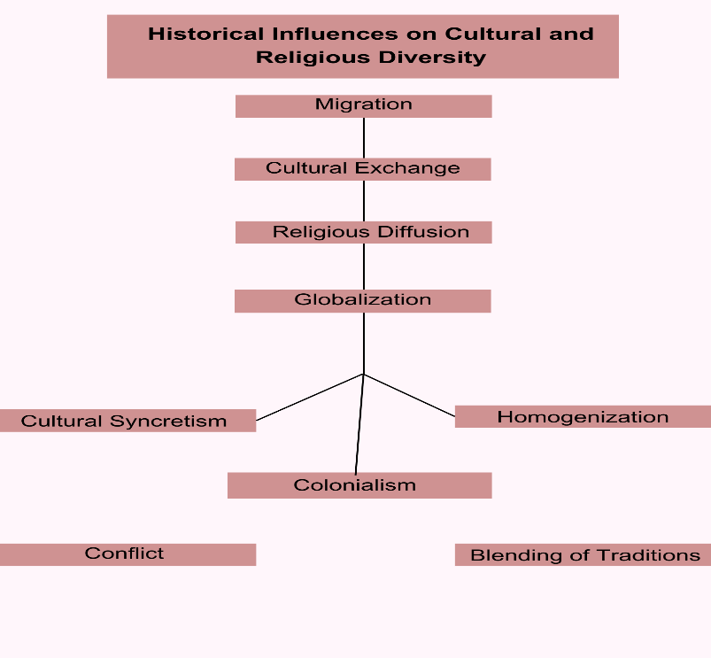

Figure 1: A flowchart illustrating the progression from migration to cultural syncretism and conflict through globalization and colonialism.

**1.3 Stereotypes and Biases**

Stereotypes and biases are among the greatest barriers to effective cross-cultural and cross-religious dialogue. These oversimplified generalizations often stem from a lack of exposure or biased portrayals, particularly in media. For example, the stereotype that "Muslims are extremists" or that "Western cultures are cold" fails to account for the vast diversity within these groups. Such biases reinforce misunderstandings and hinder genuine connections.

Media frequently perpetuates these stereotypes, emphasizing sensationalist narratives that shape public perceptions. For instance, linking terrorism predominantly with Islam has fueled widespread prejudice and fear. Overcoming these biases requires intentional effort. Education plays a pivotal role in dispelling myths by highlighting the diversity within cultural and religious groups. Direct dialogue with individuals from different backgrounds fosters personal connections that challenge preconceptions. Additionally, developing media literacy equips individuals to critically analyze and question biased representations, reducing their influence on societal attitudes.

**1.4 Essential Skills for Dialogue**

Effective cross-cultural and cross-religious dialogue hinges on three key skills: active listening, empathetic communication, and self-awareness. Active listening involves fully engaging with a speaker’s message without distractions or preconceived judgments. It emphasizes attentiveness through techniques such as paraphrasing, clarifying questions, and nonverbal cues like maintaining eye contact. For instance, listening actively to someone’s explanation of their religious practices fosters mutual understanding and trust.

Empathetic communication goes beyond listening to genuinely understanding and sharing another's feelings. This skill is particularly critical in discussions about sensitive topics like religious beliefs or cultural traditions. Techniques such as validating emotions and using non-confrontational language help participants navigate these conversations respectfully. For example, expressing appreciation for differing viewpoints rather than dismissing them strengthens relationships and encourages open dialogue.

Self-awareness is equally crucial, as it involves recognizing one’s own biases and assumptions. By reflecting on their cultural and religious identities, individuals can better understand how their perspectives shape interactions. Strategies like journaling and seeking feedback from peers enhance this self-awareness, allowing individuals to approach dialogue with humility and openness.

**1.5 Theoretical Frameworks**

Theoretical frameworks offer structured approaches to understanding cultural and religious interactions. Edward T. Hall’s cultural dimensions provide valuable insights into communication styles. High-context cultures, such as Japan, rely heavily on nonverbal cues and implicit understanding, whereas low-context cultures, like the United States, prioritize explicit verbal communication. Similarly, Hall’s concept of time orientation distinguishes between monochronic cultures, which value punctuality and sequential task completion, and polychronic cultures, which emphasize relationships and multitasking.

Milton J. Bennett’s Developmental Model of Intercultural Sensitivity (DMIS) outlines six stages of cultural sensitivity: denial, defense, minimization, acceptance, adaptation, and integration. These stages represent a progression from ignoring cultural differences to fully embracing them as part of one’s identity. For example, individuals in the denial stage may view their cultural norms as universal, while those in the adaptation stage actively adjust their behavior to bridge cultural gaps.

UNESCO’s interfaith dialogue principles further enhance the understanding of cultural and religious dynamics. These principles emphasize equality, reciprocity, inclusivity, and peacebuilding. By treating all perspectives with respect, encouraging mutual sharing, welcoming diverse participants, and promoting shared values, these principles provide a roadmap for fostering meaningful dialogue.

**1.6 Practical Applications**

The practical applications of these concepts are manifold, extending to various domains such as workplaces, communities, and educational settings. In multinational organizations, understanding Hall’s cultural dimensions can help resolve communication challenges between employees from high-context and low-context cultures. For instance, adapting communication styles to balance explicitness and contextual understanding can bridge gaps and foster collaboration.

In community settings, applying UNESCO’s interfaith principles can reduce tensions and build trust among diverse groups. For example, organizing dialogue sessions that emphasize reciprocity and inclusivity allows participants to share their beliefs and experiences, fostering mutual respect. Similarly, Bennett’s DMIS can be used in educational programs to guide students and educators through the stages of cultural sensitivity, equipping them to navigate diverse environments with empathy and adaptability.

By combining theoretical knowledge with practical applications, individuals can address the complexities of cross-cultural and cross-religious interactions, creating spaces where diversity is celebrated, and collaboration thrives.

## LESSON 2: Theoretical Models And Frameworks

**2.1 The Importance of Theoretical Frameworks**

Engaging in effective cross-cultural and cross-religious dialogue requires a solid understanding of the theories and frameworks that underpin intercultural interactions. Theoretical models provide structured ways to understand and navigate cultural and religious differences. This lesson revisits and expands on three key frameworks introduced earlier: Hall’s Cultural Dimensions, Bennett’s DMIS, and UNESCO’s Principles of Interfaith Dialogue.

**2.1.1 Edward T. Hall’s Cultural Dimensions**

Edward T. Hall’s work explores how cultural contexts influence communication and time orientation. These dimensions are particularly useful in understanding how people from different cultures perceive and respond to social interactions.

1. **High-Context vs. Low-Context Cultures**:

* In **high-context cultures** (e.g., Japan, India), communication relies heavily on nonverbal cues, shared experiences, and implicit understanding.
* Messages are often conveyed indirectly, and the context surrounding the interaction carries significant meaning. For example, in a Japanese business meeting, silence may indicate agreement or contemplation rather than disinterest.
* In contrast, **low-context cultures** (e.g., the United States, Germany) prioritize direct and explicit verbal communication. Individuals are expected to articulate their thoughts clearly without assuming shared knowledge. In these settings, silence might be perceived as a lack of preparation or uncertainty.

1. **Monochronic vs. Polychronic Time Orientation**:

* **Monochronic cultures** view time as linear and segmented, emphasizing punctuality and task completion. Countries like Switzerland and Germany often operate under this perspective, valuing schedules and deadlines above relational dynamics.
* **Polychronic cultures**, such as Mexico and Egypt, see time as flexible and fluid. These cultures prioritize relationships over strict adherence to schedules, allowing multiple activities to occur simultaneously.

| **Feature** | **High-Context Cultures** | **Low-Context Cultures** |
| --- | --- | --- |

| **Communication Style** | Implicit, relies on nonverbal cues | Explicit, direct, and verbal |
| --- | --- | --- |

| **Decision-Making** | Relationship-driven | Fact- and task-driven |
| --- | --- | --- |

| **Conflict Resolution** | Avoid confrontation to maintain harmony | Address conflict openly to resolve issues |
| --- | --- | --- |

| **Examples** | Japan, South Korea, Arab countries | Germany, United States, Switzerland |
| --- | --- | --- |

*Figure 2: A comparison of high-context and low-context cultures across communication styles, decision-making, and conflict resolution.*

Understanding Hall’s dimensions helps learners navigate cultural differences in communication and time management. By recognizing these patterns, individuals can adapt their behavior to foster smoother interactions and avoid misunderstandings.

**2.1.2 Milton J. Bennett’s Developmental Model of Intercultural Sensitivity (DMIS)**

The DMIS provides a comprehensive framework for understanding how individuals perceive and respond to cultural differences. Bennett divides these experiences into six stages, grouped into **ethnocentric** and **ethnorelative** perspectives.

1. **Ethnocentric Stages**:

* **Denial**: Individuals in this stage are unaware of cultural differences and may believe their cultural norms are universal.
* **Defense**: Cultural differences are viewed as threats. People in this stage often develop negative stereotypes about other cultures to justify their sense of superiority.
* **Minimization**: While acknowledging differences, individuals downplay them by focusing on perceived similarities, often projecting their cultural norms onto others.

1. **Ethnorelative Stages**:

* **Acceptance**: Cultural differences are acknowledged and respected as equally valid. People in this stage demonstrate openness to learning about other cultures.
* **Adaptation**: Individuals modify their behavior and communication styles to align with different cultural norms, fostering effective interactions.
* **Integration**: Cultural differences become fully integrated into one’s worldview. At this stage, individuals navigate multiple cultural contexts seamlessly, embracing diversity as a strength.

The DMIS helps learners identify their own position on the spectrum of cultural sensitivity and guides them in progressing toward ethnorelative perspectives. This progression is critical for engaging in meaningful and respectful cross-cultural dialogue.

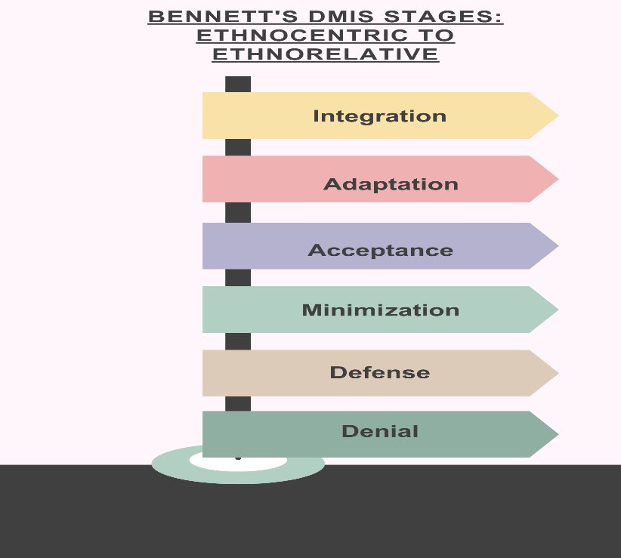

Figure 3: A flowchart showing the progression from ethnocentric to ethnorelative stages in Bennett’s DMIS.

**2.1.3 UNESCO’s Principles of Interfaith Dialogue**

UNESCO emphasizes the role of interfaith dialogue in promoting peace, understanding, and cooperation. These principles provide a practical foundation for facilitating interactions among individuals from diverse religious backgrounds.

1. **Equality**: All religious perspectives are treated with respect, without hierarchy or judgment. This principle fosters an environment where participants feel valued and heard, regardless of their faith traditions.
2. **Reciprocity**: Dialogue is a two-way process, requiring active listening and mutual sharing. By encouraging open communication, reciprocity builds trust and empathy among participants.
3. **Inclusivity**: All voices are welcomed, ensuring representation from diverse faiths and belief systems. Inclusivity enriches discussions by incorporating a variety of perspectives and experiences.
4. **Peacebuilding**: Dialogue aims to resolve conflicts and build harmonious relationships by emphasizing shared human values and common goals. This principle underscores the transformative power of dialogue in fostering understanding and cooperation.

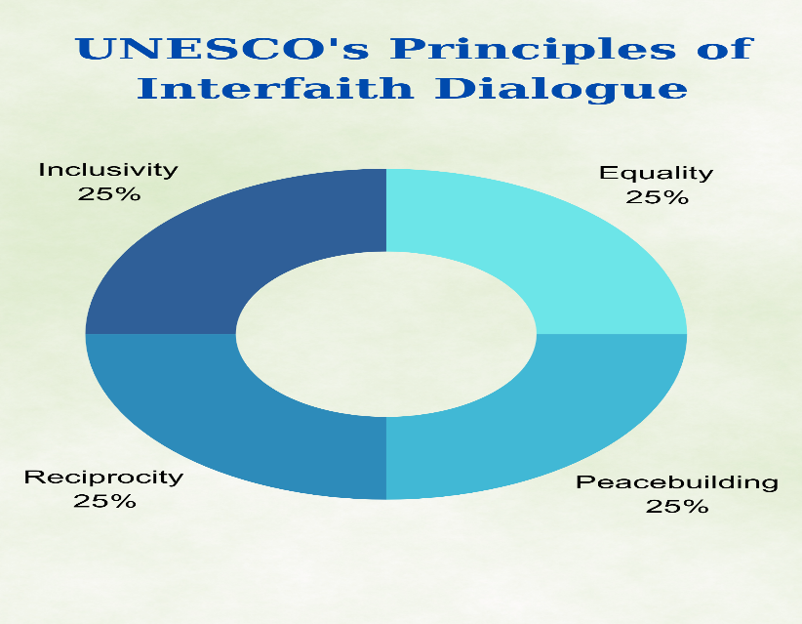

Figure 4: A breakdown of UNESCO’s four principles: Equality, Reciprocity, Inclusivity, and Peacebuilding.

UNESCO’s principles are especially relevant in contexts where religious tensions exist. By adhering to these guidelines, individuals and communities can create spaces for constructive engagement and mutual respect.

**2.2 Applying Theoretical Frameworks to Real-World Scenarios**

Theoretical models are not merely academic; they have practical applications in addressing real-world challenges.

1. **Workplace Conflict Resolution**: Imagine a multinational company experiencing tension between employees from monochronic and polychronic cultures. The monochronic employees may perceive their polychronic colleagues as disorganized, while the polychronic employees view their monochronic counterparts as rigid. By applying Hall’s dimensions, managers can facilitate understanding and encourage flexibility, creating a balanced approach to time management.
2. **Community Interfaith Dialogue**: In a neighborhood with Christian and Muslim residents, tensions may arise due to misunderstandings about religious practices. Using UNESCO’s principles, community leaders can organize dialogue sessions that promote equality, reciprocity, and inclusivity. These sessions might include shared meals, storytelling, and collaborative projects to build trust and reduce prejudice.
3. **Educational Programs**: Schools often face challenges in fostering cultural sensitivity among students from diverse backgrounds. By incorporating Bennett’s DMIS into their curricula, educators can design activities that guide students through the stages of cultural sensitivity. For example, role-playing exercises can help students move from minimization to acceptance, preparing them for interactions in a multicultural world.

**2.3 Challenges in Applying Theoretical Frameworks**

While these models offer valuable insights, their implementation can be challenging. For instance, individuals in the denial or defense stages of Bennett’s DMIS may resist efforts to promote cultural sensitivity, viewing them as unnecessary or threatening. Similarly, high-context and low-context communication styles can clash in group settings, leading to frustration or misinterpretation.

To overcome these challenges, practitioners must approach dialogue with patience, empathy, and a willingness to adapt. Providing clear explanations of theoretical concepts and their relevance can help participants understand their value. Additionally, fostering an atmosphere of trust and respect encourages openness and reduces resistance.

**2.4 Practical Strategies for Success**

Success in cross-cultural and interfaith dialogue depends on intentional effort and the application of targeted strategies. These include:

* **Education and Training**: Workshops and training sessions that introduce participants to theoretical frameworks and their applications.
* **Facilitation and Mediation**: Skilled facilitators can guide discussions, ensuring that all voices are heard and conflicts are addressed constructively.
* **Feedback and Reflection**: Encouraging participants to reflect on their experiences and provide feedback fosters continuous improvement in dialogue practices.

By combining theoretical knowledge with practical strategies, learners can effectively navigate cultural and religious differences, creating inclusive environments that value diversity.



## ASSESSMENT

1. **Multiple-Choice Questions**

**1. Which of the following is an example of a high-context culture?**

1. United States
2. Germany
3. Japan
4. Switzerland  
   Correct Answer: c

**2. In Edward T. Hall’s cultural dimensions, a polychronic culture is characterized by:**

1. Strict adherence to schedules
2. Flexibility and multitasking
3. Preference for explicit communication
4. Minimal reliance on relationships  
   Correct Answer: b

**3. Intercultural competence involves:**

1. Speaking multiple languages
2. Adapting behavior to communicate effectively with diverse groups
3. Eliminating cultural differences
4. Focusing only on similarities between cultures  
   Correct Answer: b

**4. Colonialism often led to:**

1. Preservation of indigenous traditions
2. Complete eradication of foreign influences
3. Syncretism, blending local and introduced religious practices
4. Isolation of communities  
   Correct Answer: c

**5. Which of the following is an example of nonverbal communication?**

1. Written emails
2. Body language
3. Spoken presentations
4. Written agreements  
   Correct Answer: b

**6. A low-context culture relies heavily on:**

1. Shared understanding and implicit cues
2. Nonverbal communication
3. Explicit and clear verbal messages
4. Collective rituals  
   Correct Answer: c

**7. Migration has historically contributed to cultural diversity by:**

1. Homogenizing cultural practices globally
2. Introducing and sharing traditions across regions
3. Isolating populations
4. Preventing interfaith interactions  
   Correct Answer: b

**8. High-context communication is most likely to occur in:**

1. Formal legal contracts
2. Close-knit communities with shared experiences
3. Technical instructions
4. Online customer support chats  
   Correct Answer: b
5. **Fill-in-the-Blanks Questions**
6. In high-context cultures, communication relies more on *nonverbal cues* and shared understanding rather than explicit verbal expressions.
7. The ability to interact effectively and respectfully with individuals from different cultural backgrounds is known as *intercultural competence*
8. *Colonialism* often resulted in the displacement of indigenous cultural and religious practices while introducing new systems.

1. *Polychronic* cultures emphasize relationships over strict adherence to schedules.
2. Cultural *identity* refers to shared values, traditions, and practices within a group.
3. **True/False Questions**

| **Statement** | **True** | **False** |
| --- | --- | --- |
| 1. Cultural diversity is influenced solely by historical events like migration. |  | X |
| 1. In polychronic cultures, relationships often take precedence over strict adherence to schedules. | X |  |
| 1. Stereotypes are always harmful and cannot be corrected. |  | X |
| 1. Intercultural competence involves adapting behavior to respect cultural differences. | X |  |
| 1. High-context communication relies heavily on verbal clarity and directness. |  | X |
| 1. Colonialism often led to the blending of indigenous and introduced religious practices. | X |  |
| 1. Low-context cultures rely more on implicit understanding than on explicit communication. |  | X |

1. **Matching Exercise**

Match each theory or concept with its real-world application.

| **Concept** | **Description** |
| --- | --- |
| 1. **High-Context Culture** | A) Focuses on relationships, multitasking, and flexible scheduling. |
| 1. **Low-Context Culture** | B) Adapting behavior to communicate effectively across cultural differences. |
| 1. **Polychronic Time Orientation** | C) Communication is explicit and relies on clear verbal expressions. |
| 1. **Monochronic Time Orientation** | D) Nonverbal communication is key; meaning is derived from context. |
| 1. **Intercultural Competence** | E) Values punctuality and completing tasks sequentially. |

**ANSWERS:** 1-D, 2-C, 3-A, 4-E, 5-B



## REFERENCES AND ADDITIONAL RESOURCES

**References**

Bennett, M. J. (2013). Basic concepts of intercultural communication: Paradigms and principles. Intercultural Press.

Hall, **E. T.** (1976). Beyond culture. Anchor Books.

Samovar, L. A., Porter, R. E., & McDaniel, E. R. (2015). Communication between cultures (8th ed.). Wadsworth Cengage Learning.

Ting-Toomey, S., & Chung, L. C. (2012). Understanding intercultural communication (2nd ed.). Oxford University Press.

UNESCO. (2021). Principles of interfaith dialogue. UNESCO Publishing.

**Additional Resources**

UNESCO. (n.d.). Digital library: Interfaith dialogue and cultural diversity. UNESCO. <https://www.unesco.org/en/enabling-interculturaldialogue>

Hall, E. T. (1976). Beyond culture [PDF]. <https://monoskop.org/images/6/60/Hall_Edward_T_Beyond_Culture.pdf>

Global Citizenship Foundation. (n.d.). What is culture and why does it matter? [Video]. YouTube. <https://youtu.be/CGuTfNX3iH8?si=sLA4x90tTEVu3g6q>



# SECTION 2: Practical Applications of Cross-Cultural and Cross-Religious Dialogue



## SECTION OVERVIEW

This section bridges theory and practice by focusing on the application of cross-cultural and cross-religious dialogue principles in real-world settings. Through case studies and success stories, learners will explore how to navigate complex intercultural and interfaith scenarios. The section emphasizes the importance of translating theoretical knowledge into actionable skills for resolving conflicts, building trust, and fostering inclusivity.metin, el aynası, kitap, genel ikmal maddesi içeren bir resim

Yapay zeka tarafından oluşturulmuş içerik yanlış olabilir.

Learners will analyze real-world examples demonstrating how cultural dimensions, intercultural sensitivity stages, and interfaith principles are used to address challenges in workplaces, communities, and educational institutions. Each case study highlights key strategies, such as fostering empathy, adapting communication styles, and developing culturally responsive solutions.

The section also encourages self-reflection and critical analysis by requiring learners to evaluate successes and challenges in implementing dialogue strategies. By completing structured exercises and answering debriefing questions, learners will gain practical skills to create inclusive environments that value diversity.

This section equips learners with the confidence and competence to apply their knowledge to diverse settings, ensuring respectful, productive, and meaningful engagement with individuals from various cultural and religious backgrounds.



## LEARNING OUTCOMES

gökyüzü, kişi, şahıs, bulut, top içeren bir resim

Yapay zeka tarafından oluşturulmuş içerik yanlış olabilir.

By the end of this section, learners will:

* Analyze real-world case studies involving cross-cultural and interfaith interactions.
* Identify effective strategies for addressing challenges in intercultural dialogue.
* Demonstrate the ability to apply theoretical frameworks to practical scenarios.
* Develop action plans for resolving conflicts in diverse environments.
* Reflect on the outcomes of applying intercultural and interfaith principles.
* Foster inclusivity and mutual understanding in multicultural settings.
* Build confidence in navigating complex cross-cultural and interfaith situations.
* These outcomes prepare learners to address real-life challenges using the knowledge and skills gained in the training. By engaging with practical applications, learners enhance their ability to facilitate meaningful dialogue and drive positive change in diverse communities.

## LESSON 1: Case Studies of Dialogue in Practice

This lesson introduces learners to real-world case studies that demonstrate how to apply theoretical frameworks. Learners will work through the cases step by step, using guided instructions to identify challenges, analyze cultural dynamics, and propose solutions. Multimedia resources have been included to enhance the understanding and engagement of these case studies.

**CASE STUDY 1: IMPROVING COMMUNICATION IN A MULTICULTURAL WORKPLACE**

**Scenario:**  
A global marketing agency employs individuals from diverse cultural backgrounds. The team includes members from low-context cultures, such as Germany and the United States, and high-context cultures, like Japan and South Korea. Misunderstandings arise during meetings, with low-context members preferring explicit communication and high-context members relying on nonverbal cues. These differences result in missed deadlines and frustration.

**Step 1: Identify the Problem**

* Read the scenario and summarize the key challenges. Focus on how differences in communication styles between high-context and low-context cultures contribute to misunderstandings.
* **Example:**  
  “The German and American employees (low-context) are frustrated by the lack of direct feedback from their Japanese and South Korean colleagues (high-context). For example, silence during meetings is misinterpreted as disinterest or lack of preparation, while it is intended as contemplation and agreement in high-context cultures.”
* Watch the video [**High & Low Context Cultures | Cultural Intelligence | Edward T. Hall**](https://www.youtube.com/watch?v=K5RC2gDzWEo). before summarizing the problem. Note how differences in communication styles create misunderstandings and reflect on how this relates to the challenges in the case study.

Link: <https://youtu.be/K5RC2gDzWEo?si=cjq72e0kV1hpbF3>u

**Step 2: Analyze the Problem Using Theoretical Frameworks**

* Use Edward T. Hall’s Cultural Dimensions to analyze the communication preferences and behaviors of each group.

**High-Context Cultures:** Relies on nonverbal cues, implicit communication, and shared understanding.

Example:

“Japanese employees hesitate to verbalize disagreement openly, relying instead on nonverbal signals.”

**Low-Context Cultures:** Prefers explicit, task-focused communication.

Example: “German team members expect direct instructions and clear feedback.”

* **Template for Analysis:**

| **Aspect** | **High-Context Culture (Japan, South Korea)** | **Low-Context Culture (Germany, USA)** |
| --- | --- | --- |
| Communication Style | Implicit, nonverbal | Explicit, verbal |
| Decision-Making Approach | Relationship-driven | Task-focused |
| Conflict Resolution Style | Avoid confrontation | Address conflict directly |

* Refer to [**High & Low Context Cultures | Cultural Intelligence | Edward T. Hall**](https://www.youtube.com/watch?v=K5RC2gDzWEo). to deepen your understanding of Edward T. Hall’s framework. Identify how specific behaviors in the case relate to high- or low-context cultures.

**Step 3: Propose Solutions**

* Suggest strategies to address the communication challenges using Hall’s framework and UNESCO’s Principles of Interfaith Dialogue (e.g., reciprocity, inclusivity).

**Example Solutions:**

**Cultural Awareness Training:** Organize workshops to educate team members on high-context and low-context communication styles.

**Collaborative Protocols:** Develop team guidelines for summarizing discussions in writing to ensure clarity.

**Buddy Program:** Pair employees from different cultural backgrounds to foster understanding and promote knowledge-sharing.

* Use video insights to develop practical strategies.

*Instruction:* "After watching the video, reflect on how training sessions or shared team practices can bridge the gap between communication styles."

**Step 4: Monitor and Reflect**

* Describe how to evaluate the effectiveness of the proposed solutions. Suggest methods for collecting feedback and making adjustments.

**Example:**  
“Team leaders will observe interactions during meetings and distribute anonymous surveys to gather feedback on improvements in communication and collaboration.”

**CASE STUDY 2: RESOLVING INTERFAITH TENSIONS IN A COMMUNITY SETTING**

**Scenario:**  
In a culturally diverse urban neighborhood, a community center hosts religious activities for Christian and Muslim residents. Conflicts arise over shared spaces and scheduling, leading to mistrust and reduced participation. The center leaders decide to organize interfaith dialogue sessions to rebuild harmony.

**Step 1: Identify the Problem**

* Summarize the main challenges in the scenario. Highlight how assumptions and miscommunication contribute to tensions.
* **Example:**  
  “The Christian group perceives the Muslim group as monopolizing the shared prayer space, while the Muslim group feels their scheduling requests are dismissed.”
* Watch [**Interfaith Dialogue: A Bridge of Friendship and Respect in a Globalized World**](https://www.youtube.com/watch?v=sIOc8dBvDE8). ( <https://youtu.be/sIOc8dBvDE8?si=ymnA0V4qXbn-pavM>

*Instruction:* "Before analyzing the problem, view this video to explore how interfaith dialogue principles address common challenges in shared community spaces."

**Step 2: Analyze the Problem Using Theoretical Frameworks**

* Apply UNESCO’s Principles of Interfaith Dialogue to identify potential solutions:

**Equality:** Ensure equal access to shared resources.

**Reciprocity:** Create opportunities for mutual sharing and active listening.

**Inclusivity:** Involve representatives from both groups in planning dialogue sessions.

* **Example Analysis:**  
  “By emphasizing reciprocity, both groups can share their perspectives in a structured discussion, reducing assumptions and fostering empathy.”

**Step 3: Propose Solutions**

* Recommend actionable strategies to resolve tensions and build trust.

**Example Solutions:**

**Dialogue Sessions:** Host regular discussions where participants share their traditions and religious practices.

**Collaborative Activities:** Organize joint projects (e.g., a neighborhood cleanup) to encourage teamwork and mutual respect.

**Neutral Facilitation:** Invite trained facilitators to guide discussions and ensure balanced participation.

*Instruction:* "Use insights from the video to shape your strategies, focusing on building inclusivity and fostering mutual understanding."

**Step 4: Monitor and Reflect**

* Outline methods to assess the success of these interventions.

**Example:**  
“Feedback will be collected after each dialogue session, and facilitators will observe changes in participation and attitudes over time.”

**Expected Outcomes:**

* Improved communication and collaboration in multicultural teams.
* Reduction in tensions and increased trust in interfaith community settings.



## LESSON 2: Independent Analysis of Success Stories

**Applying Theoretical Frameworks Independently**

This lesson provides learners with the opportunity to analyze additional case studies independently. Learners will apply concepts to real-world scenarios. Multimedia resources have been included to support analysis and engagement.

**CASE STUDY 1: CROSS-CULTURAL MISCOMMUNICATION IN CUSTOMER SERVICE**

**Scenario:**  
A global hotel chain receives a complaint from an international guest about the service at its Tokyo branch. The guest, an American business traveler, felt that the front desk staff’s lack of verbal communication indicated disinterest or incompetence. In contrast, the Japanese staff believed their quiet demeanor and attention to nonverbal cues demonstrated respect and professionalism.

**Step 1: Identify Cultural Dimensions**

* Use Hall’s framework to identify how the guest and staff's communication styles differ.

Example: "The American guest, from a low-context culture, expects clear and direct verbal communication, while the Japanese staff, from a high-context culture, rely on implicit cues to convey respect."

* Watch [**Cross-Cultural Communication in Customer Service**](https://www.youtube.com/watch?v=o9TlXS0ORwg).

(<https://youtu.be/o9TlXS0ORwg?si=7JzBdv0Tmb1sZItD> )

*Instruction:* "Watch this video to explore common challenges in cross-cultural customer service. Reflect on how cultural communication styles create misunderstandings."

**Step 2: Analyze Challenges**

* Explore the cultural differences that led to the misunderstanding.

Example: "The Japanese staff’s silence, intended to convey attentiveness, was interpreted as a lack of interest by the American guest, causing frustration."

**Step 3: Propose Solutions**

* Suggest practical strategies to address the communication gap.

**Example Solutions:**

**Staff Training:** Provide cultural sensitivity training for Japanese staff to better understand the expectations of international guests.

**Guest Orientation:** Share a cultural guide at check-in to help guests understand Japanese norms of hospitality.

**Blended Communication Protocol:** Encourage the use of polite verbal expressions alongside nonverbal cues to cater to low-context expectations.

* Use the video to inspire these solutions.

*Instruction:* "Refer to strategies in the video to develop specific interventions tailored to this scenario."

**Step 4: Reflect on Outcomes**

* Predict the potential results of the proposed solutions.

Example: "Improved guest satisfaction and enhanced cultural competence among staff, reducing future misunderstandings."

**CASE STUDY 2: ADDRESSING RELIGIOUS STEREOTYPES IN A UNIVERSITY SETTING**

**Scenario:**  
A university student group organizes an interfaith panel discussion. During the event, a participant from a minority faith expresses concern about being stereotyped and excluded in campus activities. This revelation sparks tension and defensive reactions from other attendees.

**Step 1: Understand the Stereotypes**

* Analyze how stereotypes arise and their impact on the panel discussion.

Example: "The minority participant’s experience of being stereotyped reflects common biases stemming from limited understanding of diverse faiths."

* Watch [**Breaking Religious Stereotypes**](https://www.youtube.com/watch?v=sIOc8dBvDE8).

(<https://youtu.be/sIOc8dBvDE8?si=53rJuHc1JTMIoCAl> )

*Instruction:* "Watch this video to gain insights into how stereotypes develop and strategies to address them in interfaith contexts."

**Step 2: Apply UNESCO’s Principles**

* Use the principles of equality, reciprocity, and inclusivity to analyze the challenges and propose solutions.

Example Analysis: "Ensuring diverse representation on the panel and encouraging active listening during discussions could have reduced tensions."

**Step 3: Design Interventions**

* Recommend initiatives to foster inclusivity and mutual respect on campus.

**Example Solutions:**

**Bias Awareness Workshops**: Host sessions to educate students on recognizing and overcoming stereotypes.

**Safe Spaces:** Create environments where students from all faiths feel comfortable sharing their experiences.

**Collaborative Projects:** Organize joint events that bring students together around shared goals, such as community service or cultural celebrations.

* Use insights from the video to shape these interventions.

*Instruction:* "Incorporate ideas from the video to ensure the initiatives address underlying biases effectively."

**Step 4: Reflect on Potential Challenges**

* Consider potential obstacles to implementing these solutions.

Example: "Resistance to change or a lack of resources might hinder progress. Developing a strong support network and seeking funding from diversity initiatives could address these challenges."

**Debriefing Questions**

**1.** How did cultural or religious differences contribute to these challenges?

2. What specific solutions did you propose for each case study?

3. How do these solutions reflect cultural sensitivity and inclusivity?

4. How might your own cultural background or biases have influenced your analysis?

5. How would you apply the lessons learned from these case studies to resolve conflicts in your workplace or community?



## ASSESSMENT

* 1. **Multiple-Choice Questions**

1. **Which principle of UNESCO’s interfaith dialogue emphasizes the need for mutual sharing and active listening?**  
   a) Equality  
   b) Inclusivity  
   c) Reciprocity  
   d) Peacebuilding  
   Correct Answer: c
2. **In Hall’s framework, which type of culture relies heavily on implicit communication and nonverbal cues?**  
   a) Low-context culture  
   b) High-context culture  
   c) Monochronic culture  
   d) Polychronic culture  
   Correct Answer: b
3. **What is the primary goal of Bennett’s adaptation stage in DMIS?**  
   a) Ignoring cultural differences  
   b) Adjusting behavior to bridge cultural gaps  
   c) Integrating cultural differences into one’s identity  
   d) Viewing cultural differences as threats  
   Correct Answer: b
4. **What was the key challenge in the hotel case study discussed in Lesson 2?**  
   a) Resource allocation  
   b) Stereotyping  
   c) Miscommunication due to cultural differences  
   d) Resistance to change  
   Correct Answer: c
5. **Which of the following is NOT a strategy proposed to improve interfaith dialogue on campus?**  
   a) Bias awareness workshops  
   b) Anonymous feedback forms  
   c) Safe spaces for open dialogue  
   d) Collaborative service projects  
   Correct Answer: b
   1. **Short-Answer Questions**
6. Describe how Hall’s Cultural Dimensions were applied in the hotel case study to address communication challenges.  
   **Model Answer:** Hall’s framework highlighted the contrast between the high-context communication style of the Japanese staff and the low-context expectations of the American guest. This understanding guided solutions such as training and blended communication strategies.
7. How could UNESCO’s principles of inclusivity and equality have improved the interfaith panel discussion at the university?  
   **Model Answer:** Ensuring diverse representation on the panel and providing equal speaking opportunities could have fostered more balanced dialogue and mitigated tensions.
8. Reflect on how personal biases might influence the analysis of the university case study. Provide an example.  
   **Model Answer:** Preconceived notions about the majority or minority faiths
9. might lead to assumptions about responsibility for the conflict, affecting impartiality in designing solutions.
   1. **Case Study Analysis**

**Scenario:**  
A regional nonprofit organization hosts a cultural festival to promote understanding between immigrant and local communities. However, some local participants express discomfort with unfamiliar cultural practices, while immigrant participants feel underrepresented in the festival’s activities.

**Instructions:**  
Analyze this scenario using the frameworks and principles covered in Section 2.

1. **Identify Key Challenges:**
   * What cultural and representational issues are evident in this scenario?
2. **Apply Theoretical Frameworks:**
   * How would Hall’s Cultural Dimensions or Bennett’s DMIS help address these challenges?
3. **Design Interventions:**
   * Propose three specific actions the organization could take to foster inclusivity and understanding at future events.
4. **Reflect on Potential Outcomes:**
   * What results could be expected from implementing these interventions?

**Model Answer:**

1. **Challenges:** Misunderstandings about cultural practices and a lack of representation for immigrant groups.
2. **Frameworks:** Hall’s dimensions could address communication gaps, and Bennett’s DMIS could guide sensitivity training for organizers and volunteers.
3. **Interventions:**
   * Include cultural workshops led by immigrant participants.
   * Create balanced representation on the planning committee.
   * Provide bilingual materials to ensure accessibility.
4. **Outcomes:** Increased community engagement, reduced tensions, and a stronger sense of inclusion.



## REFERENCES AND ADDITIONAL RESOURCES

**References**

Bennett, M. J. (2013). Basic concepts of intercultural communication: Paradigms and principles. Intercultural Press.

Hall, E. T. (1976). Beyond culture. Anchor Books.

UNESCO. (2021). Principles of interfaith dialogue. UNESCO Publishing.

**Additional Resources**

Tanaka, K. (2015). *Communication style and cultural features in high/low context communication cultures: A case study of Finland, Japan, and India*. Osaka City University. <https://www.lit.osaka-cu.ac.jp/user/tanakak/20151109kadai-4>

Meyer, E. (n.d.). *Intercultural management*. The Culture Factor. <https://www.theculturefactor.com/intercultural-management>

TEDx Talks. (2011, June 29). *The Interfaith Amigos – Breaking the taboos of interfaith dialogue* [Video]. YouTube. <https://youtu.be/tPnZArtsG_c>

UNESCO. (2005). *Teaching respect for all: Implementation guide*. <https://unesdoc.unesco.org/ark:/48223/pf0000142342>

Scarboro Missions. (n.d.). *Interfaith dialogue toolkits*. <https://www.scarboromissions.ca/interfaith-dialogue/curriculum-resources/interfaith-toolkits>

Simply Communication. (2021, July 12). *Cultural diversity in communication* [Video]. YouTube. <https://youtu.be/TyqSdmJeCro>